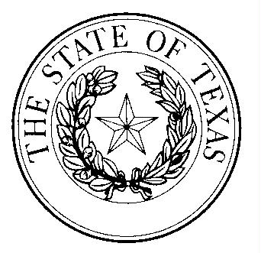

B A Y L O R C O U N T Y
OFFICE OF
COUNTY JUDGE
119 NORTH WASHINGTON ST.
SEYMOUR, TEXAS 76380

RUSTY STAFFORD, JUDGE PHONE # 940-889-3553
EMAIL judge@srcaccess.net FAX # 940-889-8856
Contact Tracing
- If a person presents to a local health care provider to include Hospitals and Clinics and testing is provided, then it is the responsibility of said provider to reach out to DSHS Region 2/3 at 1-817-264-4541 and notify them directly during business hours. If it is after hours, please call 1-817-822-6786.
- DSHS personnel will triage the call and information contained within on how to proceed. DSHS regional personnel will give guidance on how to proceed in terms of monitoring, isolation, ect.
- DSHS will notify the County EMC of any persons that need to be under public health monitoring. It will be the responsibility of the County EMC to notify their pertinent dispatch centers of the information.
- The Local Health Authority for each county will only be notified of positive cases in their county jurisdiction.
- The public health authorities will identify the person ill with COVID-19 and also individuals who have come in contact with the ill person.
- Ill person/s positive for COVID-19 will self isolate during infection and will return to normal routine after criteria are met
- Any person/s that has had contact with a positive COVID-19 case but does not have symptoms will self-quarantine for 14 days from last interaction with infected person. If no symptoms develop after 14 days, person returns to normal routine.

Tera Green, RN
Public Health Nurse
Texas Department of State Health Services
Health Services Region 2/3
Tera.green@dshs.texas.gov<mailto:Tera.green@dshs.texas.gov>
Archer City Field Office
Office 940-574-2159
Cell 682-333-6714
Fax 940-574-4049
Covers, Archer, Baylor, Clay, Jack, & Young

Dr. Adam Hertel
Baylor County Local Health Authority
Office 940-889-5583
Cell 806-392-6543

